**SCREENSHOTS**

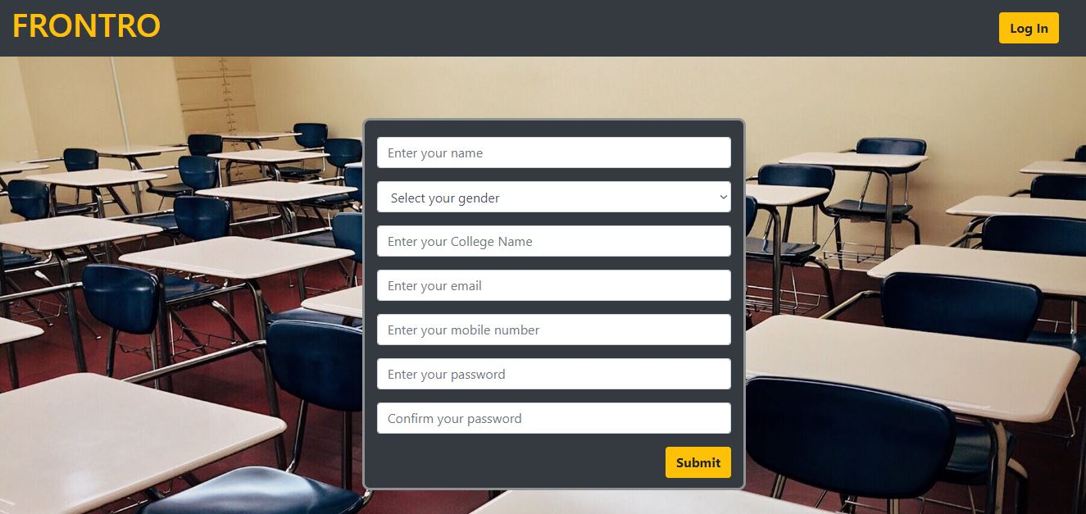

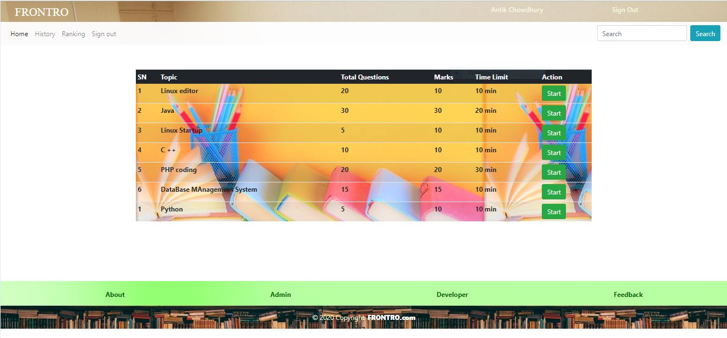

**CODE SNIPPETS:**

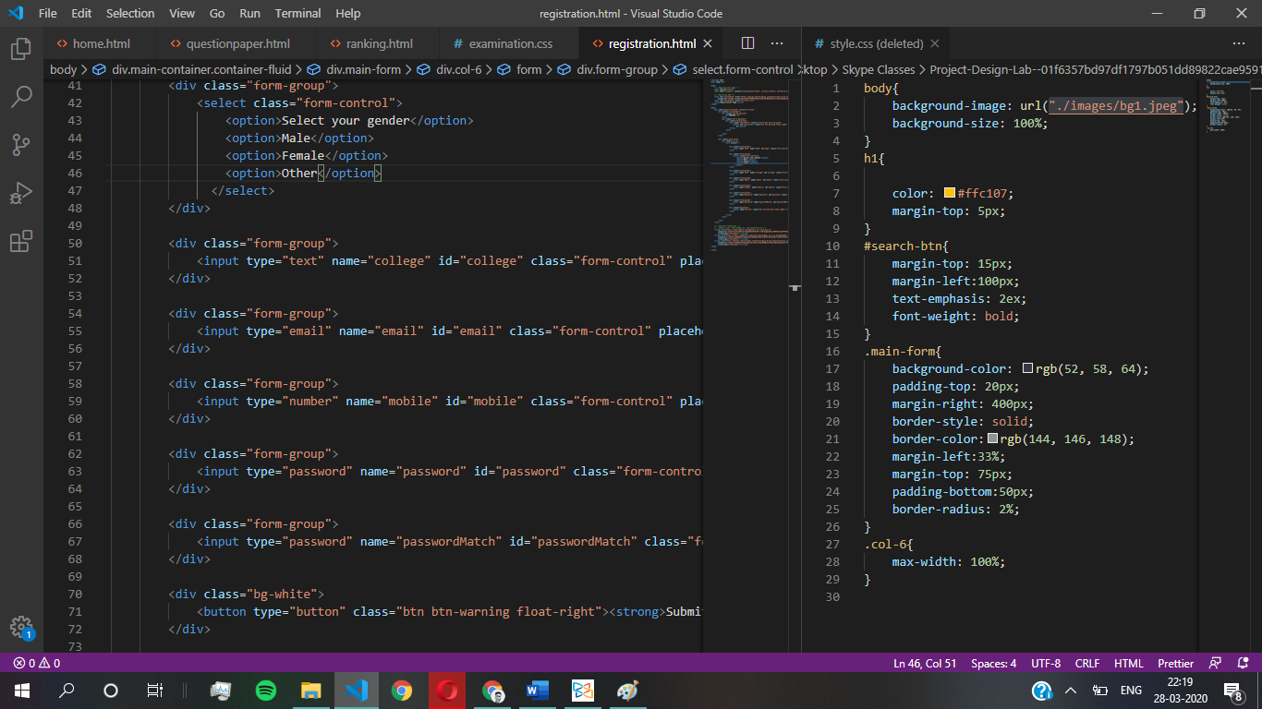

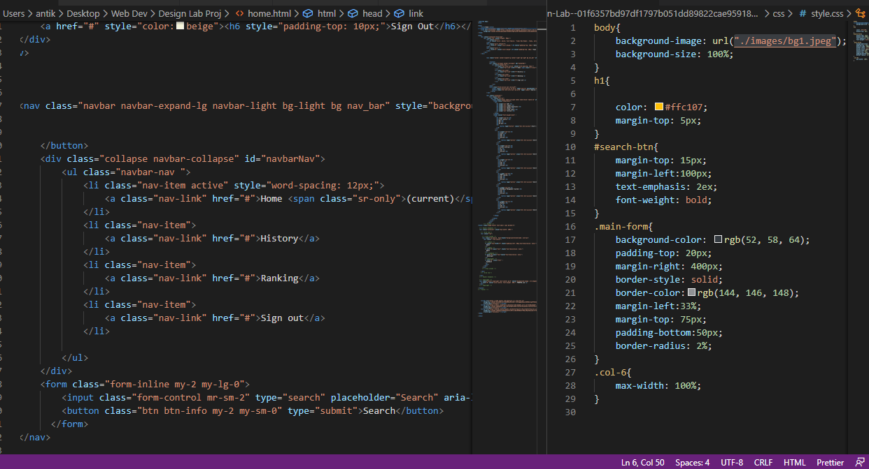

**TECHNOLOGY STACK:**

Front end: HTML, CSS, JavaScript

1. HTML: HTML is used to create and save web document. E.g. Notepad/Notepad++
2. CSS: (Cascading Style Sheets) Create attractive Layout
3. Bootstrap: responsive design mobile friendly site
4. JavaScript: it is a programming language, commonly use with web browsers.

Back end: PHP, MySQL

1. PHP: Hypertext Preprocessor (PHP) is a technology that allows software developers to create dynamically generated web pages, in HTML, XML, or other document types, as per client request. PHP is open source software.
2. MySQL: MySql is a database, widely used for accessing querying, updating, and managing data in databases

XAMPP Server

**REFERENCES:**

* Github
* W3schools
* Udemy